Pacific Sea Farms Sugar Kelp Hatchery Failures: What are the possible causes?
We have successfully grown sugar kelp all the way from spores to maturity (10’ long blades) but this year we failed 4 times to grow any seeds, and we are stumped as to what the problem(s) are thus we’re reaching out to the community for advice and guidance.
Brief background
We, Pacific Sea Farms, have a 10-acre seaweed/shellfish farm off the SW shore of Vashon Island in WA state. After a 3-year permitting/leasing process, this year (2024/25) will be our first growing season. Among others, Greenwave has been a big supporter in terms of education and guidance for us.
We are not a scientist or biologists which we mention because while we are detail and process oriented, we don’t necessarily know what questions to ask or what might be missing therefor we are reaching out to this audience for help and guidance.
Current Process
We have a “hatchery” setup in a garage that consists of four 30 gallon fish tanks and grow lights. We use Instant Ocean to create salt water. We measure/monitor for temperature (consistently 50F, PH (8.1-8.3 which matches the local water where it will be planted) and salinity (1.017). We do not measure light (PAR).
We follow the process that is detailed in the Ocean Approved “Kelp Farming Manual” which we believe to be a solid standard.
This is the kelp that we grew last year. We didn’t have the permit yet, so we put the entire seed spool in the local water and let the seeds grow. This suggests that the process and our ability to follow it are sound.
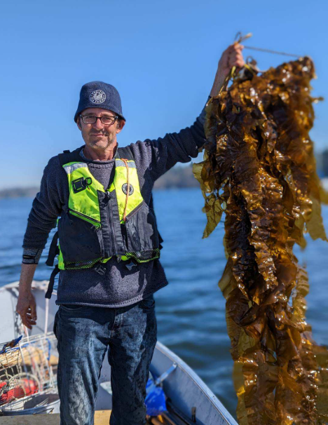

As mentioned, we followed the established process but we will list the steps taken in the hope that someone can spot a gap or potential issue so that we can have a better shot in growing seed for the ‘25/’26 season.
Here is a short video that shows the process listed below:
- Via SCUBA, we collected sorus tissue in December ‘24 from two different locations per the WA state requirements (50 individual plants from within 50 KM of the farm site).
- Within hours of collection, got cut and isolated approximately 100 pieces of sorus
- Wiped mucus from the sorus tissue
- Dipped each sample in a 3% solution of betadine for 30 seconds. To get to 3% we combined 400ml of this with 600ml of water.
  - With hindsight, we just noticed that this (below) was a 10% iodine solution whereas the previous bottle used was 5%.. this means that our math was wrong for our 2nd attempt and the iodine solution was too strong.. could it have killed the spores?
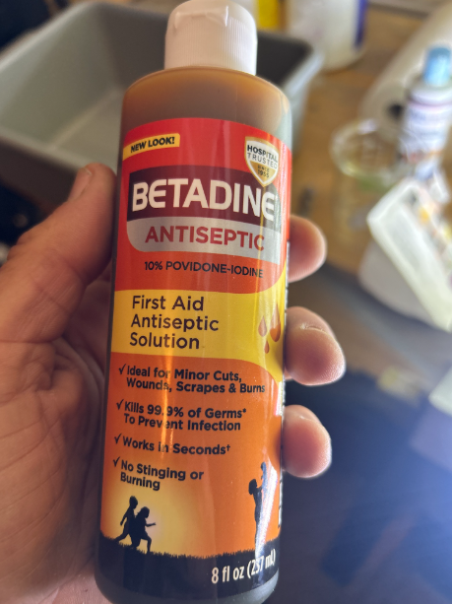
- Rinsed each sample with instant ocean salt water until the water was clear.
- Dried each sample
- Layered samples on paper towels.
- Covered all the samples and let them dry at 50F for 24 hours
- Rehydrated samples in a litre of instant ocean salt water (50F)
- Let samples soak, water temp increased to 55-60 (approx. 15-30 minutes)
- After 30 minutes we looked at a drop of solution under a microscope
- Counted spores – spore counts over the 4 different samples ranged from 750,000-1.2M per ML
- Meanwhile, tanks had been prepared in advance with proper measurements (per above).
  - The one big caveat is this: We live in a rural area and prior to this year our water source was direct from a well (no filtration or treatment). Since our last successful hatchery operation chlorination/filtration was added to the local water system. I am the neighbourhood water operator so I know quite a bit about it. Typical city water will have a chlorine level in the .5+ range. Our tap water is generally .2-.25. I assumed that even this level of chlorine wouldn’t be good for the spores so I treated the tanks with this:
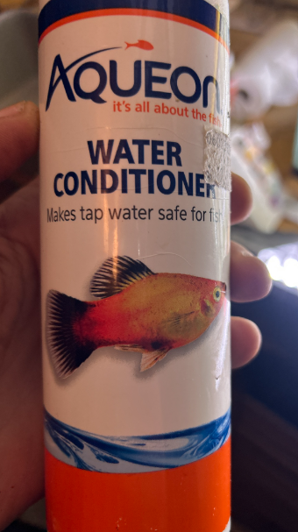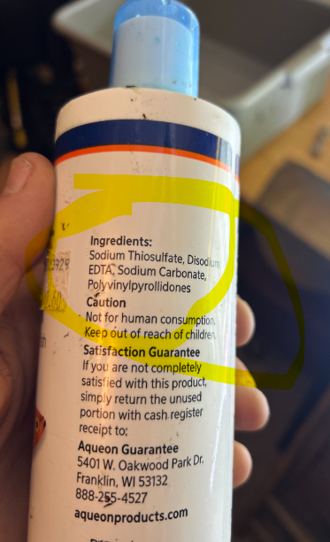
  - Our assumption is/was that this removed or otherwise nuetralized any residual chlorine in the tap water but frankly, we don’t know what this stuff does.
- We added spore solution to settling tubes that included seed spools. In two of four the tanks we did not use settling tubes.. we had the seed spools in the tank and poured the calculated amount of spore solution into the 30 gallon tank such that there would be approx 7500 spores per spool.
- Covered settling tubes for 24 hours. Used an bubbler to disrupt the water and stir up the spores in the settling tubes after 12 hours
- Removed settling tubes
- Each tank had 20 seed spools with 200’ of seed string.
- Each tank has an air bubbler
- Each week we would add 10ml of part A and 10ml of part B of this food
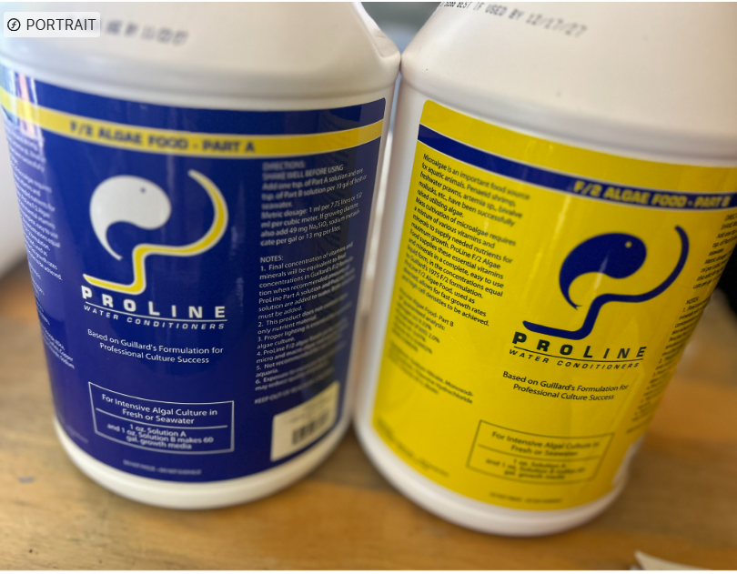

- After a few days we noticed some growth of a brown substance. We have been told that kelp wouldn’t start to “hatch/grow” until approx. day 21` so we assumed this growth was diatoms or some other foreign algae. We knew that diatoms were a kelp seed killer, and that Germanium (di)Oxide was the cure.
- We tried to acquire germanium oxide (GeO2) but couldn’t find any chemical companies willing to sell it to us as we didn’t pass their “background” checks. We’re squeaky clean but apparently the chemical companies only sell to research and/or manufacturing facilities and our garage-based hatchery didn’t pass muster. We, eventually, were able to procure some GeO2 from another source but not until day 25. Wed dosed the tanks on day 25 and day 30. We don’t know if it had any impact.
- Approximately on day 35 without any visible seaweed growth we deemed the grow out to be a failure.
- We repeated the above process again. Two tanks (40 spools) were with kelp/sori from our farm site. Two add’l tanks (30 spools) were with setup with kelp/sori procured a week later from a different site.
- As with the first round, spore counts were done (750K-1M spores/ml) and the spores were very mobile/active.)
- The results of this round were similar. No seaweed growth. Below are pix of what did appear on the spools.

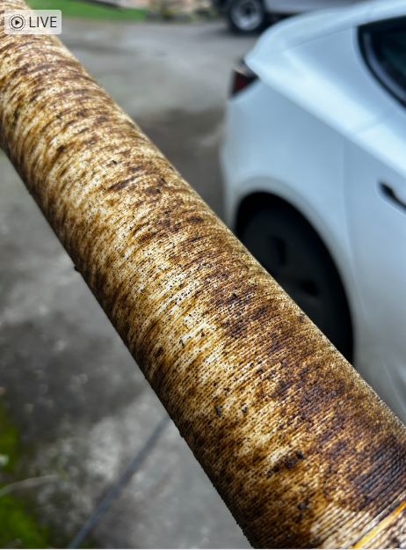

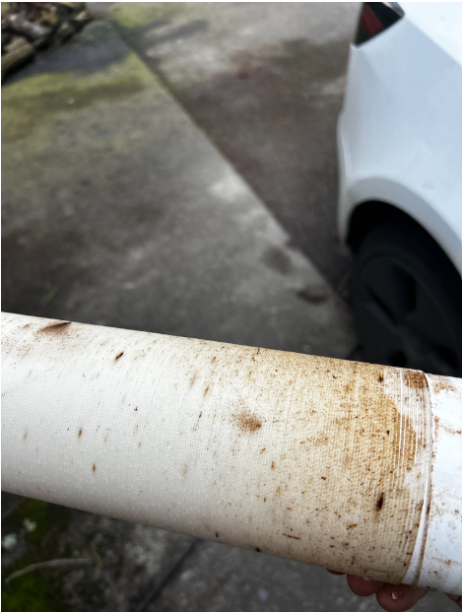

One tank had zero growth of anything
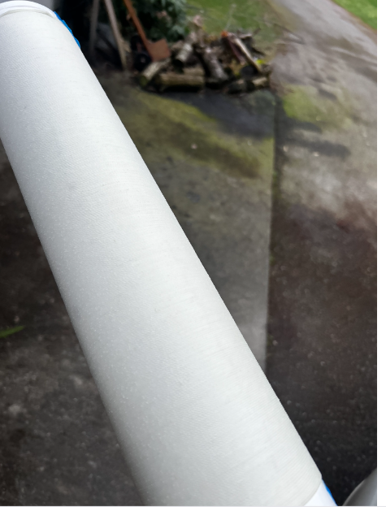

This seed string was examined under 4X (.1) power

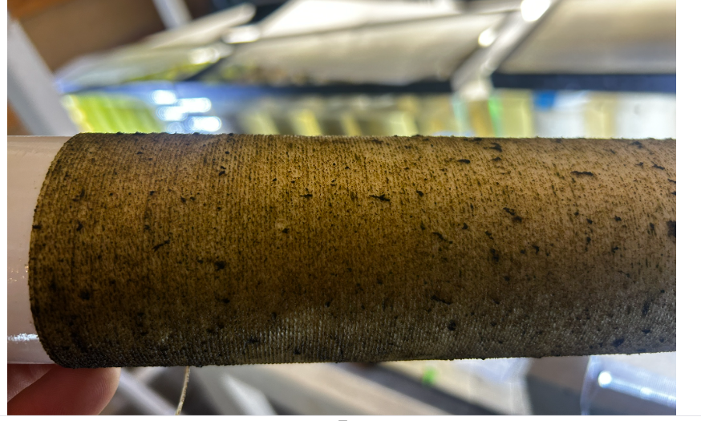

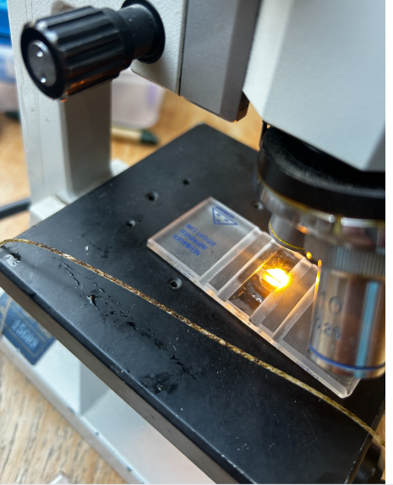

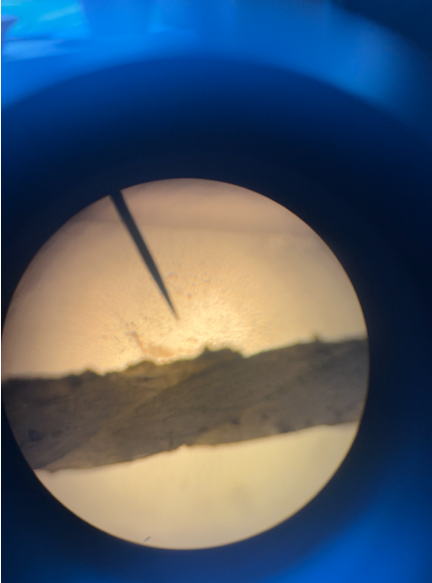

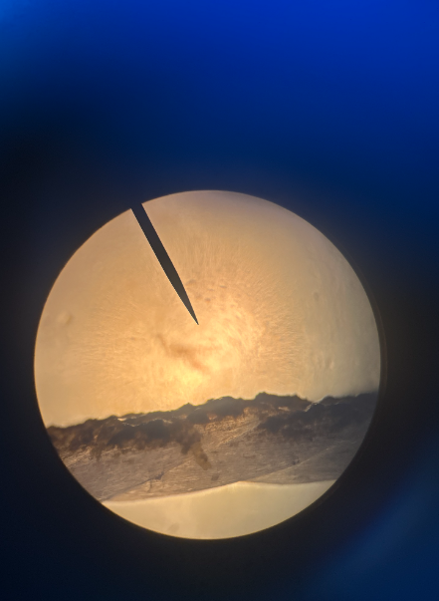

This is the brown growth smeared onto the slide:
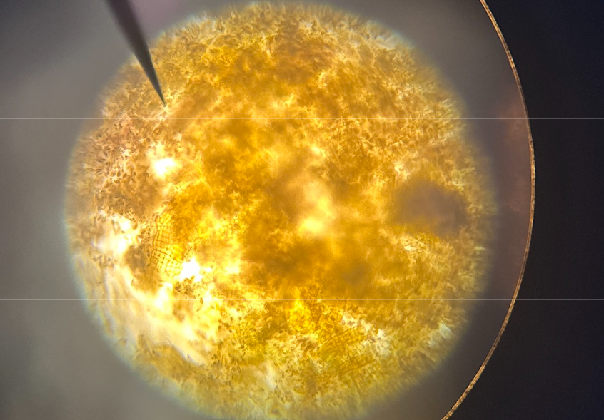

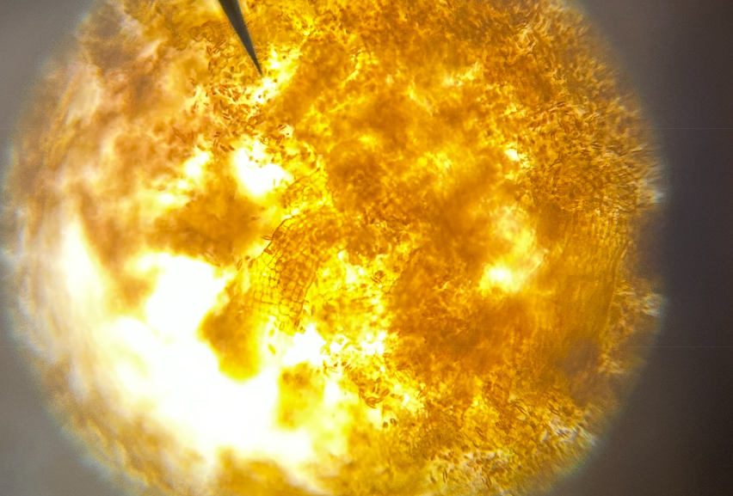
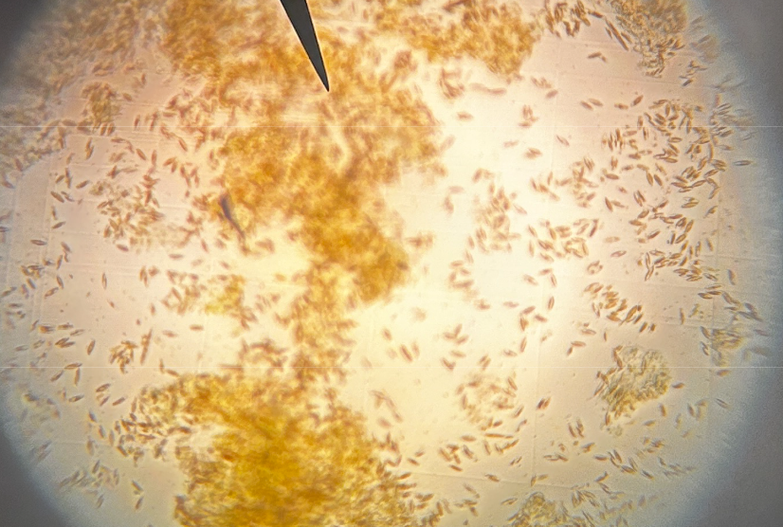

We don’t know what the stuff above is but our assumption is that it is not sugar kelp.

Things that we did NOT do that perhaps should do:
- Use a micron filter when pouring the solution of spores into the settling tubes to further reduce the risk of contamination by diatoms or other organisms
- Change the water in the tank
- Despite living on an island, near the Salish Sea, using salt water directly from the Sea isn’t practical hence the Instant Ocean.
- We’ve been told/shown a process where 10 slides are installed in the tank. Every few days a slide is removed and checked for status/growth under the microscope. We did not do this process. It’s unlikely that this would have prevented the failure, but it could have given us more information sooner in the process
- We regularly checked temp/salinity/PH and it was consistently at the appropriate levels so we did not add anything (other than food and the aforementioned Ge02) during the process.

Summary
We have had one successful hatchery process and one failure. We could chalk up the success to a solid process or simply good luck. Likewise, we could chalk up the failure to bad luck. We need to be able to reliably produce seeds for our farm so we’re looking for guidance that can help increase our odds for success.
Finally, the failure in the hatchery left us thinking we wouldn’t have a crop this year, but nature helped us out of our jam. While we were working in the hatchery a “wild set” found our lines and is currently growing well. While this is fantastic, we don’t want to rely upon this happening every year. Considering that there is healthy native sugar kelp in close proximity to the farm, the ideal scenario is that we both seed the lines and get wild set to maximize biomass potential.

